ROBOTIC ROVER ARM
PROJECT REPORT
Submitted by
By
Abhirami K S (UCE21EC001)
Aromal Gautham Suresh (UCE21EC009)
Rony Mathew (UCE21EC019)

to
the APJ Abdul Kalam Technological University
in partial fulfillment of the requirements
for the award of the Degree of
BACHELOR OF TECHNOLOGY
in
ELECTRONICS AND COMMUNICATION ENGINEERING

Department of Electronics and Communication Engineering
University College of Engineering Muttom P.O., Thoduphuzha,
Kerala-685 587
MAY 2024
DEPARTMENT OF ELECTRONICS & COMMUNICATION ENGINEERING
UNIVERSITY COLLEGE OF ENGINEERING
Muttom P. O., Thodupuzha, Kerala – 685 587

CERTIFICATE

This is to certify that the project report titled “Robotic Rover Arm”, submitted to the APJ Abdul Kalam Technological University, in partially fulfillment of the requirements for the award of the Degree of Bachelor of Technology in Electronics and Communication Engineering, is a bonafide. record of the project work carried out by the candidate, Abhirami KS (UCE21EC001), Aromal Gautham Suresh (UCE21EC009), Rony Mathew(UCE21EC019) Department of Electronics& Communication Engineering, University College of Engineering, Muttom, Thodupuzha – 685587
Mrs. KRISHNAPRIYA B Mrs. ASHALATHA P. T
Project co-ordinator Head of the Department
Dept. Of Electronics & Communication Engg. Dept. Of Electronics & Communication Engg.
University College of Engg. University College of Engg.
Muttom P. O., Thodupuzha, Kerala – 685587 Muttom P. O., Thodupuzha,Kerala–685587

STATEMENT
The dissertation titled “ROBOTIC ROVER ARM”, submitted by Abhirami KS (UCE21EC001), Aromal Gautham Suresh (UCE21EC009), Rony Mathew(UCE21EC019) , to the APJ Abdul Kalam Technological University, in partial fulfillment of the requirements for the award of the Degree of Bachelor of Technology in Electronics and Communication Engineering, is the original and independent work carried out by them in the UNIVERSITY COLLEGE OF ENGINEERING, MUTTOM, THODUPUZHA – 685587, under my supervision and guidance.

Place: Muttom Mrs. Krishnapriya B
Date: Assistant Professor
Dept. Of Electronics and Communication
University College of Engineering,
Muttom P.O., Thoduphuzha,
Kerala-685587

DECLARATION
I undersigned hereby declare that the project report “Robotic Rover Arm”, submitted for partial fulfilment of the requirements for the award of degree of Bachelor of Technology of the APJ Abdul Kalam Technological University, Kerala is a bonafide work done by me and my group members under the supervision and guidance of Mrs. KRISHNAPRIYA B and Mrs. REEJA SEBASTIAN, Assistant Professor, Dept. of Electronics & Communication Engineering, University College of Engineering, Muttom. This submission represents my ideas in my own words and where ideas or words of others have been included, I have adequately and accurately cited and referenced the original sources. I also declare that I have adhered to ethics of academic honesty and integrity and have not misrepresented or fabricated any data or idea or fact or source in my submission. I understand that any violation of the above will be a cause for disciplinary action by the institute and/or the University and can also evoke penal action from the sources which have thus not been properly cited or from whom proper permission has not been obtained. This report has not been previously formed the basis for the award of any degree, diploma, or similar title of any other University.
Place: Muttom
Date: Abhirami ks
Aromal Gautham Suresh
Rony Mathew
ACKNOWLEDGMENT
I have immense pleasure in presenting the project “ROBOTIC ROVER ARM”, I wish to place on record my sincere thanks and obligations to all those who have contributed directly or indirectly to make this project a success. First, I would like to thank the god almighty for his kind blessings upon us for the completion of this project.
I greatly acknowledge my profound gratitude to the Principal, Dr.V.G GEETHAMMA, University College of Engineering, Thodupuzha.
I express my gratitude to Mrs. ASHALATHA P.T, Head of the Department, Department of Electronics & Communication Engineering, University College of Engineering, Thodupuzha.
I am also grateful to my project co-ordinators Mrs. KRISHNAPRIYA B, and Mrs.REEJA SEBASTIAN, Assistant Professor, Department of Electronics & Communication Engineering, University College of Engineering, Thodupuzha.
I surrender my esteemed and sincere thanks to the faculty members of Electronics and communication Engineering Department for their helpful and timely suggestion.
I am also thankful to my parents and friends for their motivation and support.

ABSTRACT
Wireless communication holds a lot of importance in data acquisition systems. Radio communication is a commonly used wireless communication method. Such a communication method is used in amplitude modulation radio, frequency modulation radio, radars, satellites, televisions, telephones, etc. Radio communication can also be used for other types of applications for example sending data to communicate with hardware such as robots and making it to do specific tasks which is the objective of this paper. The prototype consists of a transmitter which is a glove consisting of four flex sensors, Arduino Uno, and a Radio Frequency (RF) transceiver module to send data to the receiver. The receiver consists of an RF transceiver module that will receive the data, which will then be processed by Arduino Mega and subsequently used to control the movements of a 6- axis robotic arm. The paper discusses the complete procedure of how the data is generated by the flex sensors, what is being done with the data, and how the data is used to control the robotic arm movements.

CONTENTS
CONTENTS | Page No.
ACKNOWLEDGEMENT
ABSTRACT
LIST OF FIGURES
ABBREVIATIONS
Chapter 1. INTRODUCTION
1.1General Background
1.2 Objective
Chapter 2. LITERATURE SURVEY
2.1“A self feeding assistive Robotic Arm For People With physical Disabilities Of The Extremities”
2.2 “Integration of Home Assistance With a Gesture Controlled Robotic Arm.”
2.3 “Gesture Controlled Robotic Arm Utilizing OpenCV”
2.4 “The Research And Design of Smart Mobile Robotic Arm Based On Gesture controlled”
2.5“Human-Machine Interface( HMI) Robotic Arm Controlled By Gyroscopically Acceleration”
Chapter 3. EXISTING SYSTEM
3.1 What Is This System And How It Works
3.2 Block Diagram
3.3 Block Diagram Explanation
3.5 Circuit Diagram
3.6 Prototype Of The System
Chapter 4. PROPOSED SYSTEM
4.1 What Is The System
4.2 Block Diagram
4.3 Working
4.4 Components Required
4.5 Software Requirements
Chapter 5. CONCLUSION AND FUTURESCOPE
5.1 Application Of The System
5.2 Advantages
5.3 Conclusion
5.4 Future Scope
REFERENCES

LIST OF FIGURES
No. | Title | Page No.
2.1.1 | Experimenting result of robotic arm | 14
2.1.2 | Experimental Setup of transferring water task | 15
2.1.3 | Experimenting setup of eating food task | 16
2.2.1 | Arm in action | 17
2.2.2 | Joint angles | 18
2.3.1 | System structure diagram | 19
2.3.2 | Manipulator open control following gesture | 20
2.4.1 | 3D printed arm connected to raspberry pi via bread board | 21
2.5.1 | Block diagram of system connection components. | 24
2.5.2 | Basic 5DOF based robotic arm design | 25
3.2 | Block diagram | 28
3.3 | Circuit diagram | 29
3.4 | Prototype of the system | 30
4.2 | Block diagram | 32
4.5.1 | ESP32 Micro controller | 35
4.5.2 | Flex sensor | 36
4.5.3 | MPU6050 Gyroscope | 36
4.5.4 | Zigbee transmitter | 37
4.5.5 | Wireless camera | 38
4.5.6 | L293 Motor driver | 39
4.5.7 | Servo motor | 39
4.5.8 | Zigbee receiver | 40
4.5.9 | Wires | 41
4.6.1 | Arduino IDE software | 41
4.6.2 | CAD design software | 42
4.6.3 | Proteus software | 43

LIST OF TABLES
No. | Title | Page No.
2.2.1 | Efficiency of system | 18
4.4 | Components Used | 34

ABBREVIATIONS
RF | Radio Frequency
DoF | Degree of Freedom
LP | Leap Motion
LED | Light Emitting Diode
DC | Direct Current
SVM | Support Vector Machine
CV | Computer Vision
GPIO | General Purpose Input Output
HMI | Human Machine Interface
FIR | Finite Impulse Response
PWM | Pulse Width Modulation
RAM | Random Access Memory
PCB | Printed Circuit Board
IMU | Inertial Measurement Unit
DMP | Digital Motion Processor
IOT | Internet Of Things
USB | Universal Serial Bus
IDE | Integrated Development Environment
CAD | Computer Aided Design

CHAPTER 1

INTRODUCTION
1.1 GENERAL BACKGROUND
The advancement of robotics has opened new frontiers in exploration , automation, and problem solving across various environments .this project focuses the development of a robotic rover arm , a versatile tool designed to perform tasks in challenging terrains, including planetary surfaces, disaster zones, and remote locations on the earth.Gesture-controlled robotic arms are an innovative intersection of robotics and human-computer interaction. This technology allows users to manipulate a robotic arm using hand movements, offering intuitive control for various applications, from education to industrial automation.

In the current world scenario, the usage of wireless applications is increasing at a high rate with ever increasing demand for systems able to communicate with each other and exchange data. This paper discusses the implementation of a prototype that controls a robotic arm using flex sensors wirelessly. The robotic arm used has a 6-axis freedom of movement and is capable of pick and place operation.

Gesture-controlled robotic rover arms represent a significant advancement in robotics, combining ease of use with sophisticated technology. As this field evolves, we can expect more intuitive and powerful systems that enhance human capabilities across various sectors. Despite of their potential, the deployment of robotic rover arm also faces challenges,such as high cost, need for sophisticated maintenance, and the requirement for operators to undergo specialized training. Moreover the technology is evolving, with ongoing research aimed at improving the autonomy, reliability, and versatility of these robots.

1.2 OBJECTIVE
The Gesture-controlled robotic rover arms represent a significant advancement in robotics, combining ease of use with sophisticated technology. As this field evolves, we can expect more intuitive and powerful systems that enhance human capabilities across various sectors. A robotic rover arm is a robotic system designed to perform various tasks on a planetary surface or in a remote environment.
The primary objectives of a robotic rover arm are like sampling and collection is one of the main objectives , to collect and store samples from the environment, such as rocks, soil, or other materials. This is crucial for scientific research and analysis, as it allows scientists to study the composition and properties of the samples in a laboratory setting. Manipulation and experimentation is the other objective which can be used to manipulate objects and conduct experiments on the planetary surface. Maintenance and repair means the other objective which means of be used to perform maintenance and repair tasks on the rover itself, such as replacing faulty components or cleaning solar panels. Navigation and mobility means of to assist with navigation and mobility, such as by providing additional traction or stability on uneven terrain. Also has an inevitable role in scientific research by providing a flexible and versatile tool for conducting experiments and collecting data on the planetary surface.These objectives are critical to the success of robotic rover missions and beyond.
The objectives of a robotic rover arm are multifaceted and play a crucial role in the success of robotic rover missions. Overall, the objectives of a robotic rover arm are critical to advancing our knowledge of the solar system and pushing the boundaries of space exploration as well as to hospital and other environments

1.3 Existing System
- What Is This System And How It Works.
A robotic rover arm system is a flexible arm that allows a rover to maneuver instruments and perform tasks like collecting samples. A robotic rover arm is designed to be robust and survive in unknown environments. The arm has multiple joints, similar to a human arm, that allow it to move in a variety of ways.
Pre-Operation:
1. Power-up: Activate the robotic rover arm's systems.
2. Self-test: Perform diagnostic checks on arm components.
3. Initialization: Set arm configuration, calibration, and parameters.

- Operations
- Command Receipt:
Receive commands from control center or onboard computer. Decode and interpret commands (e.g., move arm, collect sample).
- Arm Movement:
Actuate joints moves arm segments using motors or actuators. Control arm trajectory: Regulate movement speed, acceleration, and deceleration. Monitor arm position: Use sensors (e.g., encoders, potentiometers) for real-time feedback.
- End-Effector Operation:
Deploy end-effector (e.g., gripper, drill, spectrometer), Perform task (e.g., sample collection, drilling, analysis), Store or transmit data (e.g., sample, sensor readings).
- Arm Retraction:
Reverse arm movement by return arm to initial position. Secure end-effector will stow or lock in place.
- Status Update:
Transmit status report by send arm status, task completion, and any errors. Receive new commands by updating task list or adjust arm configuration.
Post-Operation:
1. Shutdown: Deactivate arm systems.
2. Diagnostic check: Run post-operation diagnostics.
3. Maintenance: Perform routine maintenance (e.g., lubrication, inspection).
A robotic rover arm is a complex system that integrates mechanical, electrical, and software components to perform tasks on planetary surfaces or other environments. It operates by receiving commands from a control center or onboard computer, then actuating its jointed segments to move and position its end-effector tool. Sensors provide real-time feedback on position and enabling precise control. The arm executes tasks such as sample collection, drilling, and data transmission, before retracting and securing the end-effector. Autonomous modes allow onboard computers to control the arm based on pre-programmed tasks or sensor inputs, while safety features include emergency shutdown, fault recovery, and redundancy. Overall, the robotic rover arm combines precision, adaptability, and autonomy to efficiently execute tasks in challenging environments.

1.4 Block Diagram.

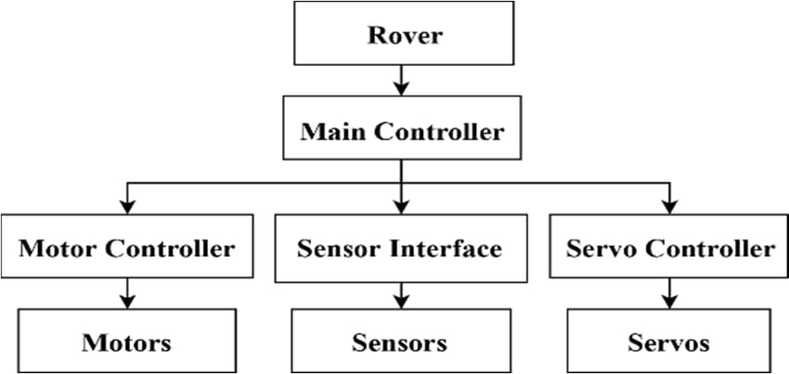
Fig:1.4 Block diagram

1.5 Block Diagram Explanation

Robotic rover arm represents the overall system, encompassing all the components and functionalities.A robotic rover arm is a tool that helps rovers perform a variety of tasks, including collecting samples, digging trenches, and operating science instruments.
Main Controller is the central processing unit that governs the rover's operations. It receives commands from the user and coordinates the actions of other components. Motor Controller unit manages the motors responsible for driving the rover's wheels or other locomotion mechanisms. Sensor Interface component interfaces with the rover's various sensors, collecting data about its environment. Servo Controller unit controls the servos, which are used for precise movements such as steering, manipulating robotic arms, or adjusting camera angles. Motors physical actuators that generate motion for the rover. Sensors gather information about the rover's surroundings, such as cameras, proximity sensors, and temperature sensors. Servos are small motors with precise position control, often used for fine-grained movements.
In summary, the Main Controller acts as the brain, receiving commands and coordinating the actions of the Motor Controller, Sensor Interface, and Servo Controller to achieve the desired rover behavior.
1.6 Circuit Diagram

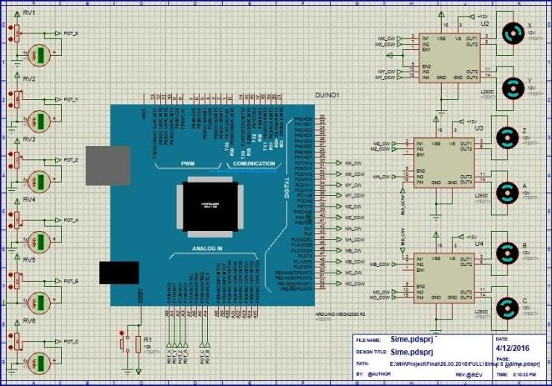
Fig:1.6 Circuit diagram of existing system

1.7 Prototype of The System

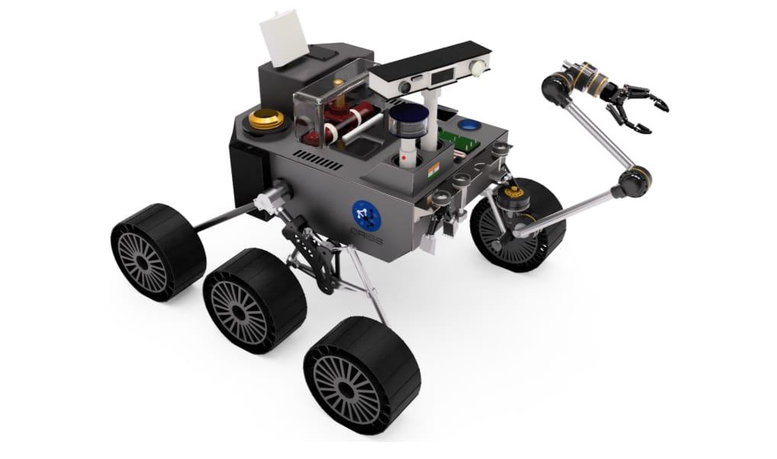
Fig:1.7 Prototype of the system

CHAPTER 2

LITERATURE SURVEY

2.1 “A Self-Feeding Assistive Robotic Arm for People With Physical Disabilities Of The Exetremities”.

Authors: Shotaro Gushi, Yuichi Shimabukuro and Hiroki Higa

The paper presents a self- feeding assistive robot self- feeding assistive robotic arm designed for individuals with severe disabilities, featuring seven degrees of freedom (DoF) to achieve human-like arm movements during meals. A robotic arm simulator was utilized to generate the necessary motions for the real arm. Two experiments were conducted ; one involved transferring water between bowls, and the other focused on eating tasks.

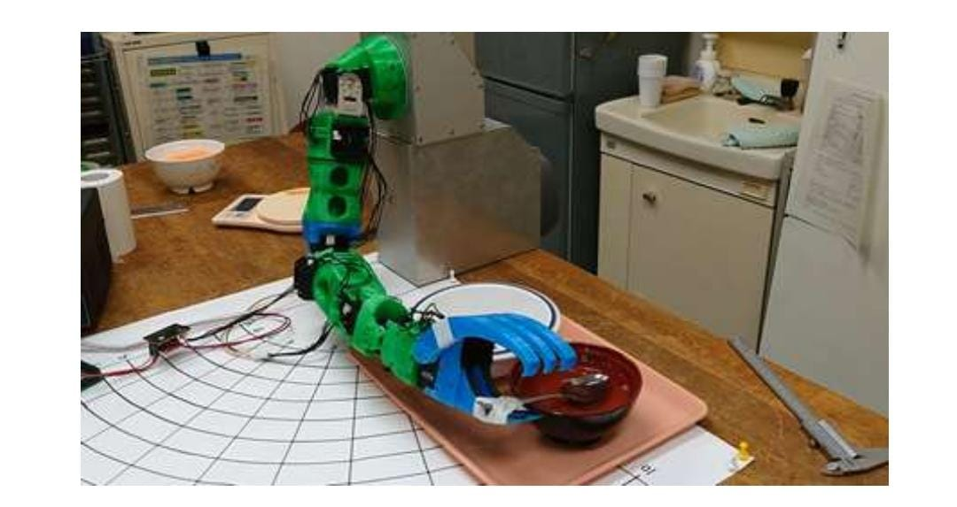
Fig: 2.1.1 Experimenting result for Robotic Arm

The results indicated that the robotic arm system successfully transferred over 80% of both water and food to their intended locations. The increasing number of individuals with disabilities, due to illness, accidents, or aging, has highlighted the challenges faced by caregivers and the impact on the dignity of care-receivers. Many existing self-feeding assistive robotic arm systems, such as My Spoon, Handy 1, i-Arm, and Jaco, are limited in their usability and compatibility with various bowls, which restricts the dining experience for those they aim to assist. In response to these challenges, our research has developed a self-feeding assistive robotic arm specifically designed for individuals with physical disabilities, including those resulting from stroke, spinal cord injury, and muscular dystrophy. This robotic arm features seven degrees of freedom (DoF) to mimic natural human movement during meals. By utilizing a simulator for control, the robotic arm can be operated remotely, allowing us to conduct experiments involving transferring water and eating various foods such as corn soup, miso soup, and rice porridge, thereby enhancing the eating experience for users. The self-feeding assistive robotic arm designed for individuals with muscular dystrophy, employing a 7-degree-of-freedom (DoF) mechanism to mimic human arm movements for tasks like scooping creamy foods. The system comprises a 7-DoF robotic arm, a personal computer, an Arduino Mega 2560 microcontroller, and a DC power supply, with servo motors serving as actuators. Control signals from the PC manage the servo motors, which are directly connected to DC power lines to accommodate their high current demands.
In an experimental setup for a water transfer task, a robotic arm was positioned between two bowls on a table, with 170 g of water placed in bowl 1. The experiment aimed to measure how much water was successfully transferred to bowl 2, following a pre-experimental simulation where the arm's movements were logged for optimal performance. Servo 1 operated at a 12-bit resolution of 4095 steps, while the other servos functioned at a 10-bit resolution of 1023 steps.
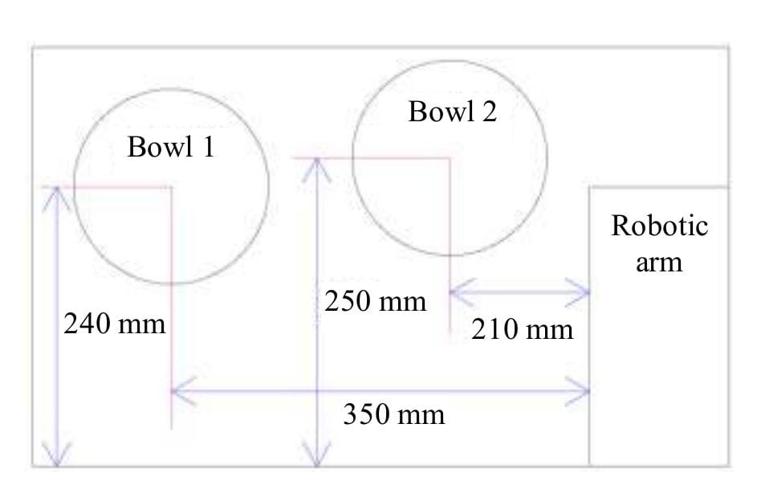
Fig: 2.1.2 Experimental Setup of transferring water task.
In an experimental setup for an eating task, a robotic arm was placed on a table with bowl 1 containing corn soup, miso soup, and rice porridge. Using a simulator, we designed motions for the arm to scoop food from the bowl and transfer it to a user's mouth. The robotic arm was then operated using this motion data to confirm its effectiveness. Participants used the spoon provided by the arm to eat and pressed the PC's enter key after each spoonful. The experiment concluded if the robotic arm failed to scoop food, and we measured both the amount of food scooped and consumed by the subjects.
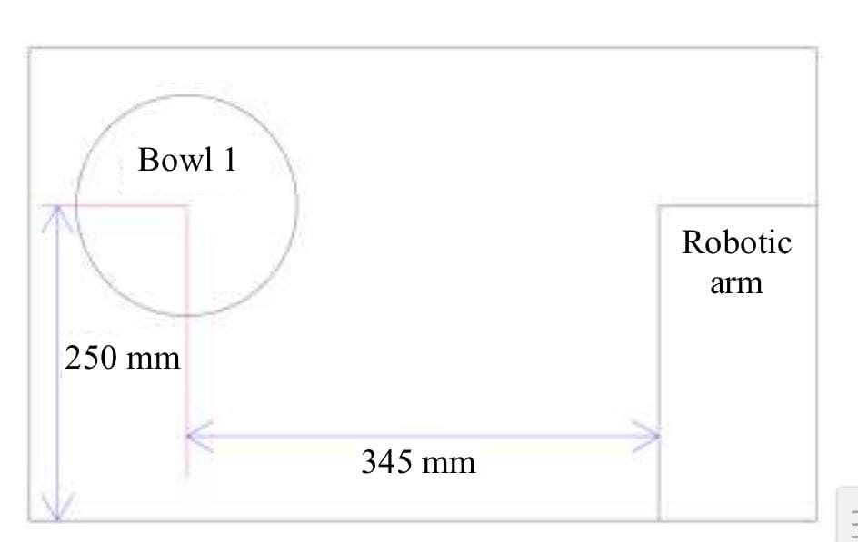
Fig: 2.1.3 Experimental setup of eating food task.

2.2 “Integration Of Home Assistance With A Gesture Controlled Robotic Arm”

Authors:Jahidul Islam, Amit Ghosh, Md Ifraham Iqbal, Sadaf Meem and Nazib Ahmad

Technology has advanced significantly, leading to the development of artificial intelligence (AI) robots that are designed to assist with various human activities, particularly in humanitarian roles. Modern robots can perform tasks like housekeeping and other manual labor, often programmed to operate remotely without the need for human intervention.

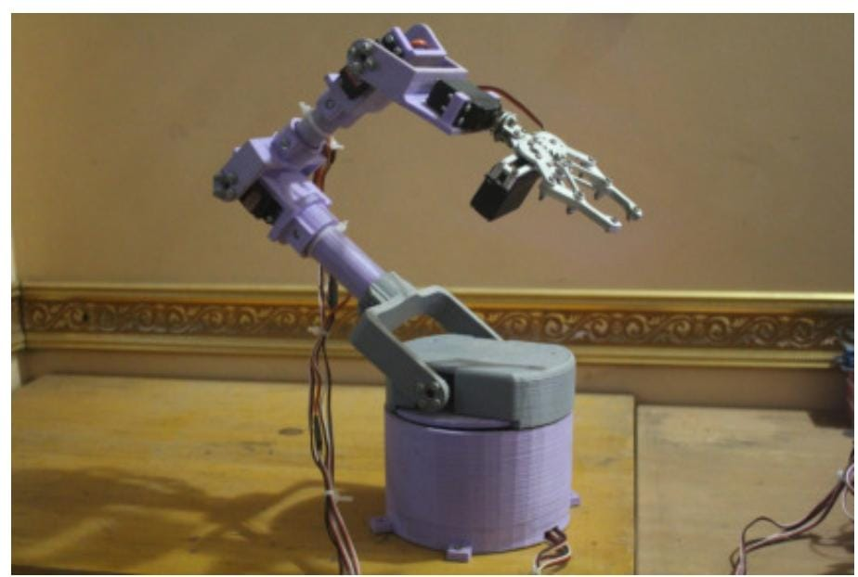
Fig: 2.2.1 Arm in action

This paper discusses a specific robotic arm enhanced with Leap Motion technology.
Leap Motion technology tracks hand movements with precision, calculating joint angles to enable the robotic arm to mimic human gestures accurately, which is crucial for its acceptance in household settings. Gesture-controlled devices are particularly beneficial for individuals with disabilities, providing them greater autonomy and boosting their confidence.
Robotics has led to innovations like prosthetic limbs and devices for the disabled, enhancing their quality of life and independence. The target mission of our robot is to assist children, the elderly, and those with disabilities, providing companionship and aiding with household tasks.
The robot is designed as a standalone IoT-based humanoid that can respond to gestures, text, and voice commands, enabling seamless interaction. It is equipped with various sensors to monitor environmental conditions, enhancing its functionality as a humanitarian assistant. The Leap Motion (LP) sensor, featuring wide-angle cameras and infrared LEDs, detects hand and finger movements, translating them into commands for the robotic arm.
Previous robotic arm models faced limitations in command variety and internet connectivity, making them less user-friendly and adaptable.The integration of Leap Motion technology offers superior accuracy and allows the robotic arm to better imitate human-like movements for tasks around the house.
The proposed system combines the LP sensor with a Raspberry Pi and an Arduino Mega 2560 for precise control of the robotic arm’s movements.The robotic arm features six degrees of freedom (DoF), enhancing its flexibility and ability to perform complex tasks similar to human movements. Using DC motors and servo motors, the arm mimics the mechanics of a human limb, allowing for tasks such as lifting, pulling, and precise manipulation.
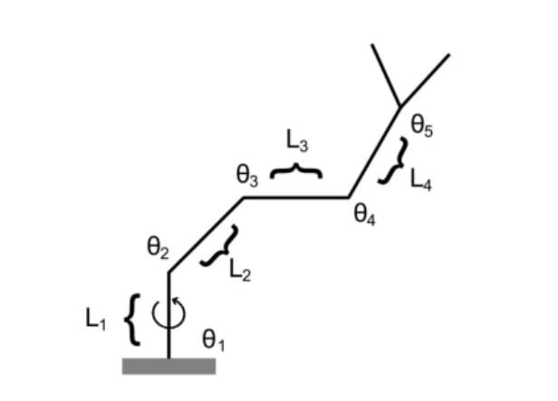
Fig: 2.2.2 Joint angles

A joint trajectory control system ensures the robotic arm operates smoothly, minimizing unwanted shaking and enhancing stability during tasks. The software development includes gesture recognition via Support Vector Machine (SVM) algorithms, which allows for quick and accurate command processing.Data mapping is crucial, as it translates the LP sensor's coordinates into actionable commands for the robotic arm, ensuring precise movement based on user gestures.
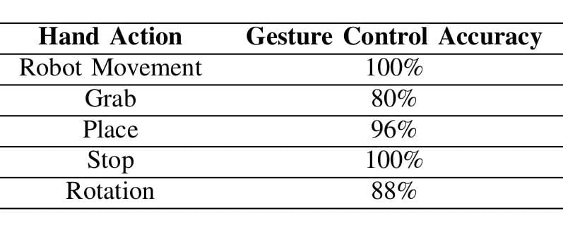
Table: 2.2.1 Efficiciency of system

Testing showed that the system performs with an average efficiency of 92.8%, demonstrating strong capabilities in recognizing and executing user commands. While the robotic arm is effective, improvements can be made by increasing the number of fingers and enhancing the sensory range to ensure better performance in complex environments.

2.3 “The Research And Design Of Smart Mobile Robotic Arm Based On Gesture Controlled”

Authors:Hongli He and Yongping Dan

The paper presents a smart mobile robotic arm controlled by gestures, utilizing a remote-controlled smart car equipped with a robotic arm. The Leap Motion module captures 3D hand positions, converting them into control data via the Processing API on a PC. Communication occurs through Bluetooth, with an STM32 NUCLEO-F411RE board processing the gesture data. Left-hand gestures control the car's movement, while right-hand gestures generate PWM signals for the robotic arm's elbow, wrist, and gripping actions. Experimental results demonstrate accurate and rapid responses, allowing for various remote control functions based on gestures.
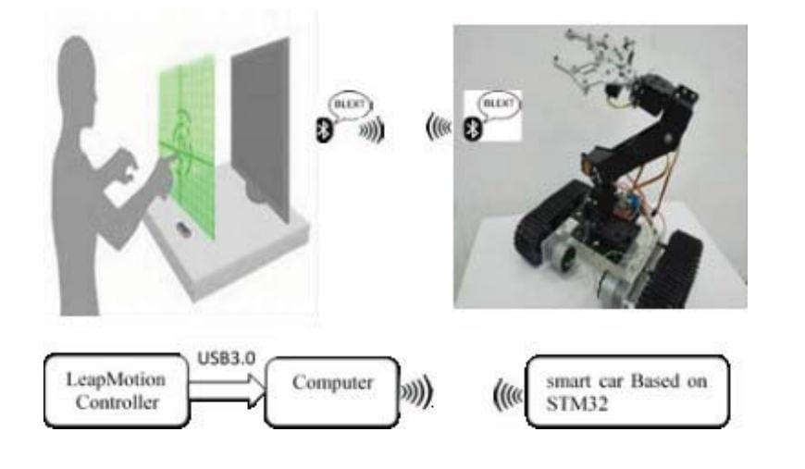
Fig: 2.3.1 System structure diagram.
The Leap Motion sensor serves as the gesture recognition device in this system, employing stereo vision to determine the spatial coordinates of hand movements with high accuracy. This technology enables the robotic arm to interpret various gestures for control. The robotic arm system consists of three primary modules: the Leap Motion sensor for gesture recognition, a PC for data analysis, and an STM32-based smart car control module. This structure allows for effective communication and control based on gesture inputs. The Leap Motion sensor captures gesture data and communicates with the PC via USB 3.0. The PC processes this data using the Leap Motion API, obtaining various parameters related to hand movements, which are then sent to the smart car system via Bluetooth. The STM32 microcontroller processes the received gesture data. Left-hand gestures are translated into control commands for the car's movement, while right-hand gestures generate PWM signals for controlling the robotic arm's movements. The hardware consists of several components, including the Leap Motion sensor for gesture recognition, an STM32 development board for car control, and a Bluetooth communication module (HC-05) for data transmission.
The HC-05 module facilitates wireless communication between the PC and the STM32 board, allowing for seamless data exchange without additional circuitry, enhancing the system's usability. The robotic arm employs five servos, controlled through PWM signals, to facilitate elbow, wrist, and grip movements. Each servo's position is adjusted based on gesture inputs received from the Leap Motion sensor. Different components of the system require specific voltages. The power supply design incorporates voltage regulation to ensure stable operation across all devices involved. The software on the PC is responsible for gesture recognition and processing. It captures data from the Leap Motion sensor, analyzes it, and sends control commands to the car and robotic arm. Car movements are governed by the left hand's position in the gesture recognition space. The system interprets these positions to control direction and speed, resembling joystick functionality.
The robotic arm's wrist and elbow movements are based on gesture parameters retrieved from the Leap Motion sensor. This allows for nuanced control of the arm's position in space. The robotic arm uses a single-grip mechanism controlled by gesture parameters indicating the degree of grip. This is achieved by interpreting the hand's shape and position as it mimics gripping an object. Elbow movements are calculated using the coordinates of the arm's wrist and elbow. This information is processed to ensure accurate servo movement corresponding to user gestures.
The system underwent rigorous testing to validate the accuracy and responsiveness of the gesture controls. Each part of the system was adjusted to ensure seamless operation during trials. Experimental results indicate that the robotic arm responds effectively to gestures, allowing for precise manipulation tasks. The combination of hardware and software achieves reliable operation.
This gesture-controlled robotic arm can replace humans in various dangerous tasks, providing a safer alternative for performing operations in hazardous environments. Further studies could explore the integration of additional sensors and enhanced algorithms to improve gesture recognition accuracy and expand the robotic arm's capabilities.
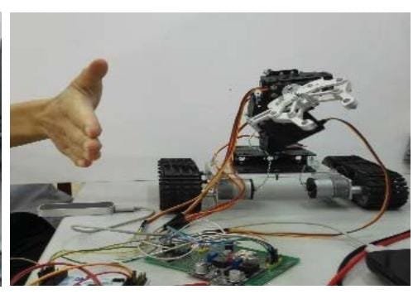
Fig: 2.3.2 Manipulator open control following gesture.

The development of this intelligent mobile robotic arm system demonstrates the potential of gesture control technology in robotics, showcasing effective user interaction and operational efficiency. In summary, the system provides a robust framework for non-contact human-computer interaction, allowing intuitive control of a mobile robotic arm, driven entirely by user gestures.

2.4 “ Gesture-Controlled Robotic Arm Utilizing OpenCV”

Authors: Jedidiah Paterson and Dr. Ahmed Aldabbagh

The paper presents a low-cost, 3D-printed robotic arm controlled by gesture recognition through computer vision, utilizing a single USB2.0 HD camera and the OpenCV library. This system translates hand movements into commands sent to a Raspberry Pi, which interfaces with the robotic arm. By using computer vision for human-computer interaction, the design reduces components and costs. The Raspberry Pi controls the arm's servo motors while monitoring pressure sensors and limit switches to prevent overextension and protect the integrity of objects being handled.
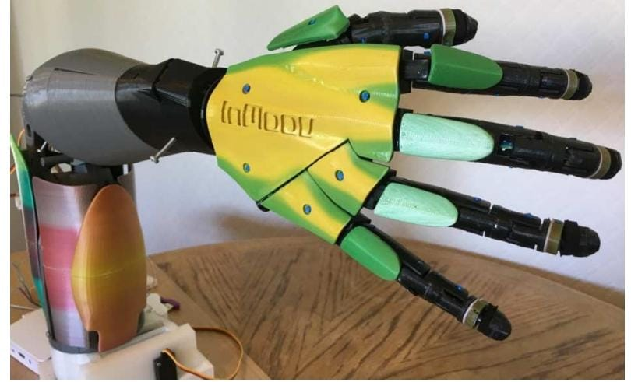

Fig: 2.4.1 3D printed arm connected to raspberry pi via bread board.

There are two primary methods for gesture recognition: the Data Glove method, which involves wearing a specialized glove with sensors, and the Computer Vision method, which tracks hand movements using camer. The Data Glove method boasts high accuracy (over 95%) due to its sampling rate but is limited by high costs, potential accuracy drift over time, and discomfort during prolonged use. Computer Vision (CV) systems can monitor multiple hands, create touchless public devices, and are more accessible since cameras are ubiquitous and do not restrict natural hand movements. CV methods face challenges including background interference, sampling rates for real-time processing, and the need to accurately represent a 3D hand in 2D images.OpenCV's background subtraction technique can help mitigate background noise and interference, allowing for clearer gesture detection.
Improving sampling rates can be achieved by utilizing higher-spec cameras, like the Design Spark camera at 30 FPS, while more advanced models, like the Sony PXWFS5, provide even higher rates but at increased costs. The Hidden Markov model is often employed in CV applications to estimate the positions of unseen parts of the hand based on previously observed location. The project tested two affordable cameras: a built-in ASUS Notebook camera (17 FPS) and a HUE HD Camera (up to 30 FPS), to evaluate their effectiveness in gesture recognition.
A Raspberry Pi 3 Model B was selected for controlling the robotic arm due to its upgrade-able options and numerous GPIO pins, making it suitable for interfacing with various components. The robotic arm was printed using two 3D printers with PLA filament, based on the InMoov robot design, featuring multiple servo motors for articulation.
Key software packages utilized included OpenCV for image processing, QT Creator for coding in C++, and Cura for preparing 3D print files. The system is designed for real-time control of the robotic arm, minimizing computational effort through filtering, isolation, and command control. Users calibrate the system by covering two designated red squares on the camera frame with their hand, which helps filter background noise.
`Methods for isolating the hand involve Gaussian blur, HSV conversion, threshold detection, and morphological processing to refine the image for gesture detection. Identifying hand features is critical; edge detection and finger detection help in recognizing hand gestures accurately, which is essential for control. The control system employs quadrant control and hand pose detection, utilizing geometric calculations to determine the hand's position and issue corresponding command. The system communicates wirelessly with the Raspberry Pi using internet protocols, sending command words that dictate servo motor movements.
Testing confirmed the arm's responsiveness to gestures, but suggestions for improvement include enhancing color calibration, detecting individual finger movements, and using an Arduino for better PWM control. This project demonstrates that a simple, cost-effective gesture recognition system can be developed using computer vision, paving the way for future advancements in gesture-controlled robotics.

2.5 “Human-Machine Interface (HMI) Robotic Arm Controlled By Gyroscopically Acceleration.”

Authors:Roshni Parvin, Rafi Al Adnan, Mohammad Rejwan Uddin, and Mahady Hasan

The article presents a "Human-Machine Interface Robotic Arm" utilizing the MPU 6050 sensor to detect hand motion in any direction. The system features five degrees of freedom, allowing for base rotation, arm and elbow movements, grip actions, and grip rotation. Users can control the robotic hand to grasp, operate, and move objects according to their intentions, ensuring real-time responsiveness and performance. This setup guarantees safety and adaptability, making it suitable for precise object manipulation in both industrial and everyday tasks.
Despite advancements in robotics, precise labor often requires human oversight. Robotic arms are utilized in tasks like welding, screwing, and painting, with many humanoid arms featuring over six degrees of freedom. Standard control mechanisms include joysticks that can transmit limited commands, while six-axis force/torque sensors, though precise, are costly and not user-friendly.Human presence is still essential for high-precision tasks, prompting the development of a Human-Machine Interface (HMI) robotic arm to enable robots to imitate human actions. In industrial contexts, HMIs range from simple touchscreens to advanced systems with 3D cameras that detect body movements. The primary goal is effective control of machines.
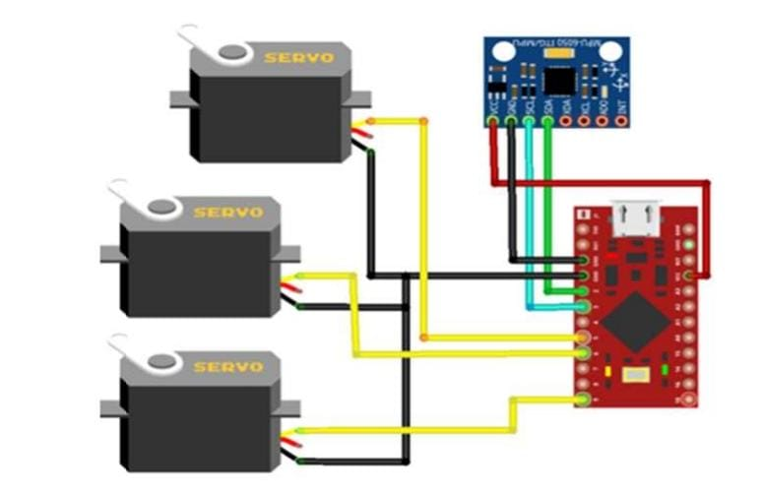
Fig: 2.5.1 Block diagram of system connection components.
The project features a 2-axis servo robotic arm controlled by an MPU-6050 sensor, which m easures acceleration and angular velocity using MEMS technology. The HMI robotic arm addresses increasing workload demands by enabling humans to direct robotic actions, ensuring precision in tasks difficult for human habitat. While some worry about job displacement, the design emphasizes human involvement, maintaining employment while aiding in heavy or challenging tasks.
The assembly process begins with connecting various components, including the acrylic robotic arm and sensors, enabling 360-degree movement control. The robotic arm is designed with five degrees of freedom, allowing various movements through pitch, yaw, and roll, enhancing versatility. The design incorporates a mechanical model for rotation, allowing for precise movement detection and control via the MPU6050 sensor. To eliminate noise from the sensor data, a low-pass FIR filter is employed, ensuring accurate movement tracking of the robotic arm.
The system calculates the arm's position using Newton's laws, incorporating accelerometer data to determine dynamics and eliminate disturbances. Key hardware includes servo motors, Arduino boards, and the MPU6050 sensor, which enables gesture tracking and arm replication. The MPU6050 sensor detects human hand movements, converting them into joint angles for the robotic arm through inverse kinematics. A Bluetooth network allows communication between the sensor and the robotic arm, facilitating effective control over a distance. The robotic arm utilizes servos to replicate human gestures, with precise joint movements achieved through coded instructions.
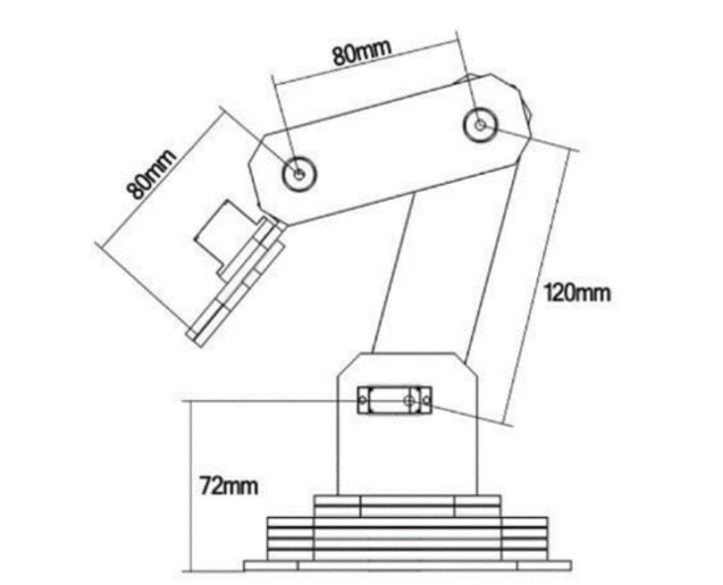
Fig: 2.5.2 Basic 5DOF based robotic arm design.

Trial movements were conducted to evaluate accuracy, yielding high percentages across various degrees of freedom, ensuring reliable operation. The total cost for developing the HMI robotic arm was approximately 4,935 BDT, primarily allocated to the acrylic arm and Arduino component.
The proposed HMI robotic arm showcases effective human gesture control for complex tasks, addressing challenges in medical and industrial applications while maintaining cost-efficiency. This innovative system not only enhances robotic precision but also emphasizes the necessity of human oversight, promising a collaborative future for humans and robots in various fields.

CHAPTER 3
EXISTING SYSTEM
3.1 What Is This System And How It Works.
A robotic rover arm system is a flexible arm that allows a rover to maneuver instruments and perform tasks like collecting samples. A robotic rover arm is designed to be robust and survive in unknown environments. The arm has multiple joints, similar to a human arm, that allow it to move in a variety of ways.
Pre-Operation:
1. Power-up: Activate the robotic rover arm's systems.
2. Self-test: Perform diagnostic checks on arm components.
3. Initialization: Set arm configuration, calibration, and parameters.
Operations
- Command Receipt:
Receive commands from control center or onboard computer. Decode and interpret commands (e.g., move arm, collect sample).
- Arm Movement:
Actuate joints moves arm segments using motors or actuators. Control arm trajectory: Regulate movement speed, acceleration, and deceleration. Monitor arm position: Use sensors (e.g., encoders, potentiometers) for real-time feedback.
- End-Effector Operation:
Deploy end-effector (e.g., gripper, drill, spectrometer), Perform task (e.g., sample collection, drilling, analysis), Store or transmit data (e.g., sample, sensor readings).
- Arm Retraction:
Reverse arm movement by return arm to initial position. Secure end-effector will stow or lock in place.

- Status Update:
Transmit status report by send arm status, task completion, and any errors. Receive new commands by updating task list or adjust arm configuration.
Post-Operation:
1. Shutdown: Deactivate arm systems.
2. Diagnostic check: Run post-operation diagnostics.
3. Maintenance: Perform routine maintenance (e.g., lubrication, inspection).
A robotic rover arm is a complex system that integrates mechanical, electrical, and software components to perform tasks on planetary surfaces or other environments. It operates by receiving commands from a control center or onboard computer, then actuating its jointed segments to move and position its end-effector tool. Sensors provide real-time feedback on position and enabling precise control. The arm executes tasks such as sample collection, drilling, and data transmission, before retracting and securing the end-effector. Autonomous modes allow onboard computers to control the arm based on pre-programmed tasks or sensor inputs, while safety features include emergency shutdown, fault recovery, and redundancy. Overall, the robotic rover arm combines precision, adaptability, and autonomy to efficiently execute tasks in challenging environments.

3.2 Block Diagram.


Fig:3.2 Block diagram.

3.3 Block Diagram Explanation.

Robotic rover arm represents the overall system, encompassing all the components and functionalities.A robotic rover arm is a tool that helps rovers perform a variety of tasks, including collecting samples, digging trenches, and operating science instruments.
Main Controller is the central processing unit that governs the rover's operations. It receives commands from the user and coordinates the actions of other components. Motor Controller unit manages the motors responsible for driving the rover's wheels or other locomotion mechanisms. Sensor Interface component interfaces with the rover's various sensors, collecting data about its environment. Servo Controller unit controls the servos, which are used for precise movements such as steering, manipulating robotic arms, or adjusting camera angles. Motors physical actuators that generate motion for the rover. Sensors gather information about the rover's surroundings, such as cameras, proximity sensors, and temperature sensors. Servos are small motors with precise position control, often used for fine-grained movements.
In summary, the Main Controller acts as the brain, receiving commands and coordinating the actions of the Motor Controller, Sensor Interface, and Servo Controller to achieve the desired rover behavior.

3.4 Circuit Diagram


Fig: 3.4 Circuit diagram of existing system.

3.5 Prototype Of The System.



Fig: 3.5 Prototype of the system.

CHAPTER 4
PROPOSED SYSTEM
4.1 What Is This System.
A robotic arm is a type of mechanical arm, usually programmable, with similar functions to a human arm; the arm may be the sum total of the mechanism or may be part of a more complex robot.
The robotic arm is also designed and manufactured with seven degree of freedom which is useful to assist the rover for multiple purposes such as to collect the soil samples for testing, to open and close the taps or valves and also to assist the astronaut for picking up tools like screwdriver, cutting player, etc. during an emergency.

Key Components
1. Arm Structure: Jointed segments with actuators (motors, hydraulic) which is useful to assist in multiple purpose such as to collect.
2. End-Effector: Tools required (gripper, drill, spectrometer) for task to allow the robot to interact with object and its environment.
3.Sensors:Position, force, torque, temperature, and environmental sensors can be used to collect the data and drive the robotic machines.
4.Control System:Controller, software, and algorithms can be used allowing users to define the task, for scalability and for advanced analysis that manages the arms movement.
5. Power Source: Batteries, solar panels, or fuel cells can be used.

Operation Sequence
1. Command Receipt: Receive instructions from control center or onboard computer as input.
2. Arm Movement: Actuate joints, control trajectory, and monitor position to the motion of the arms joints and segments to perform tasks.
3. Task Execution: Deploy end-effector, perform task (sample collection, drilling)execution.
4. Data Transmission: System that send and receive the status b, sensor data, and task results between the arms onboard system.
5. Arm Retraction: It is the process of returning the arm to its initial position, reverse movement, secure end-effector.

Control and Autonomy
1. Autonomous Mode: Onboard computer controls arm based on pre-programmed tasks or sensor inputs.
2. Tele-operation: Human operator can controls arm remotely usimg communication networks and specialized structures.

How It Works:
1. Initialization: The robotic rover arm initializes and calibrates its path.
2. Task Planning: Control center or onboard computer plans tasks to be performed.
3. Arm Movement: Actuators move arm to desired position and that’s how the arm movement is decided.
4. Task Execution: End-effector performs the desired task.
5. Sensor Feedback: Continuous monitoring and adjustment is made possible through the sensors feedback.
6. Data Transmission: Arm sends the status and task results to be performed.
7. Shutdown: Arm powers down when the desired task is done.

4.2 Block Diagram
A Block diagram for a Robotic Rover Arm involves several components tailored to its functionality and environment. Below, outlines a typical block diagram design for such a robot, focusing on essential elements like sensors, actuators, power management, and communication.

4.3 Working.
The block diagram of the proposed system as shown above in figure .Let us look at the block diagram of A Robotic Rover Arm.
The diagram illustrates a wireless motion-controlled robotic arm system with two main sections:- The ransmitter Section and The Receiver section. The transmitter section consists of microcontroller, power supply, flex sensors, gyroscope and a Zigbee transmitter and The receiver section consists of microcontroller, power supply, wireless camera, motor driver, servo motors and a Zigbee receiver.
In the transmitter section , the user who controls the robotic arm controls with their arm movements. Flux Sensor 1 & 2 are attached to the user's body to detect motion and orientation of the arm movement. Power Supply is provided in the transmitter section which provides the power to the transmitter section components. ESP32 Microcontroller is the brain of the transmitter section, which helps in processing sensor data and sending control signals. Zigbee Transmitter of 433 MHz sends the control signals wirelessly to the receiver section.
In the receiver Section, Power Supply is also provided to give power to the receiver section components. Zigbee Receiver of 433 MHz is also been used in the receiver section in which it receives control signals from the transmitter section. ESP32 Microcontroller is also been used in the processesing of the received signals and controls the robotic arm's movements. L293D Motor Driver is an motordriver which controls the speed and direction of the servo motors. Servo Motors (Right Arm, Left Arm) are the motors that control the movement of the robotic arm's joints. Wireless Camera is the another main component which transmits the video footage from the robotic arm's perspective.
System Operation:
The human moves their arms, generating motion data captured by the flux sensors. The ESP32 microcontroller in the transmitter section processes this data. The processed data is transmitted wirelessly via the Zigbee transmitter. The Zigbee receiver in the receiver section receives the control signals. The ESP32 microcontroller in the receiver section interprets the signals and commands the L293D motor driver. The motor driver operates the servo motors, causing the robotic arm to mimic the human's movements. The wireless camera transmits video footage of the robotic arm's actions.

4.4 Block Diagram

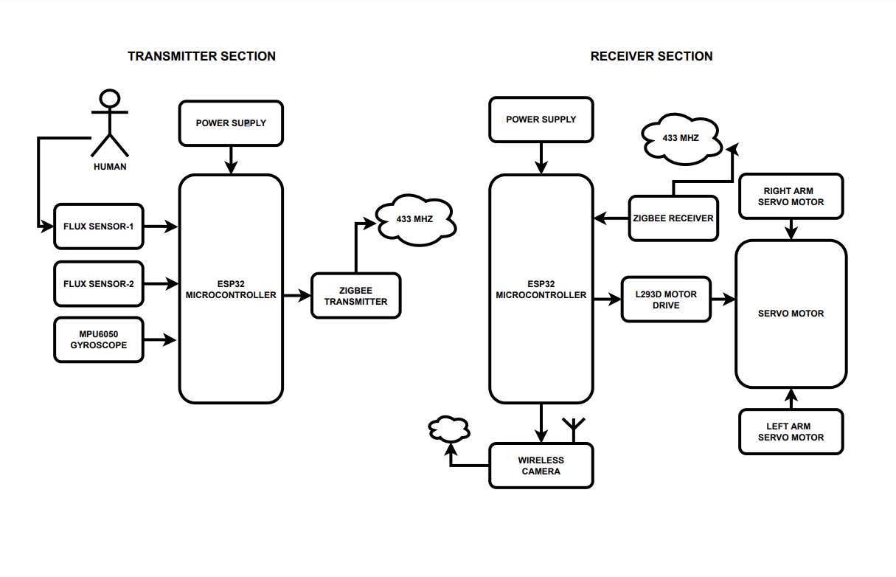
Fig: 4.4.1 Block Diagram

4.4 Components Used
SI. NO | COMPONENTS | QUANTITY
01. | ESP32 Micro-controller | (2)
02. | Flex sensor | (2)
03. | MPU6050 Gyroscope | (1)
04. | Zigbee transmitter | (1)
05. | Wireless camera | (1)
06. | L293 Motor driver | (1)
07. | Servo motor | (2)
08. | Zigbee receiver | (1)
09. | Wires | As per required
Table: 2.2.1 Components use
4.5 Components Description
- ESP32 Micro-controller
The ESP32 is a versatile and widely-used microcontroller and Wi-Fi/Bluetooth system-on-chip (SoC) produced by Espressif Systems. A SoC, is essentially an integrated circuit that takes a single platform and integrates an entire electronic system onto it, for an specific application. Contrary to a simple microcontroller (like Atmega324p Arduino Uno), that offers several general usage peripherals instead of a specific set of tools for one application. In the case of ESP32, this was designed to be an IoT SoC with already integrated Wifi, Bluetooth, and Cryptographic hardware acceleration to allow the user to access the internet. You can check it in the next diagram that specifies all its peripherals:
Additional to this, the ESP32 chip comes integrated with 4Mb FLASH and around 500 Kb of RAM. This is fundamental to support IP and TLS stack and all the matters related to internet communication that consume too much resources. Even using Wifi or BT you still have extra ram for the rest of the code. And in the worst scenario you can always get better spec chips with integrated PSRAM of 8Mb and 32Mb of Flash.
The most important thing is, if we need to change to a higher memory capacity, we can still use the same code with a couple of simple configurations. Without needing to wire or design a new PCB like most of the microcontrollers in the market.

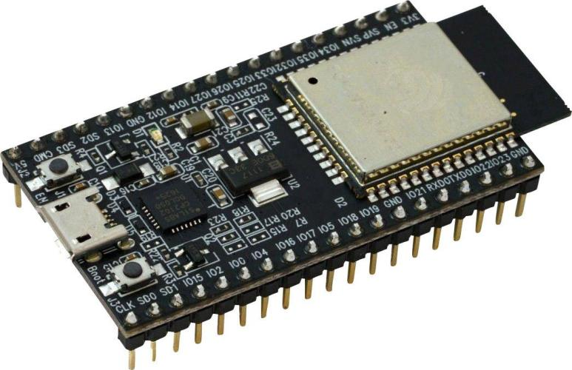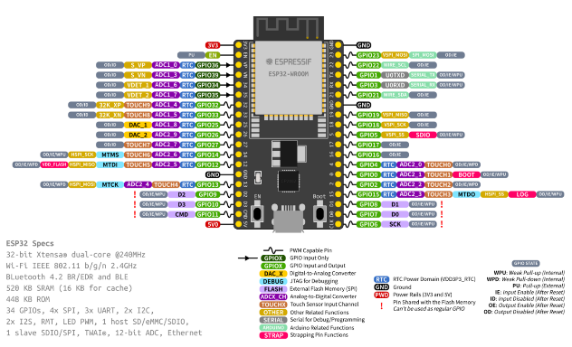

Fig: 4.5.1 ESP32 Microcontroller. Fig:4.5.2 Pinout Diagram

Features:
- Microcontroller: Tensilica Xtensa 32-bit LX6 Microprocessor
- Digital I/O Pins: 14 (of which 6 provide PWM output)
- Analog Input Pins:16
- Clock Speed: 80 MHz to 240MHz
- Wireless connectivity: The ESP32 supports Wi-Fi 802.11 b/g/n/e/i and Bluetooth v4.
- Interfaces: The ESP32 can interface with other systems through SPI/SDIO or I2C/UART interfaces.
- Programming: The ESP32 can be programmed using the Arduino IDE.
- SRAM: 520 KB
- Operating teperature:Ranging from -40°C to +125°C.
- Power Consuption:Low power consuption.

- Flex sensor
A flex sensor, also known as a bend sensor or flexible potentiometer, is a device that measures how much something has bent or deflected. It works by increasing the resistance in a circuit when it's bent, and the amount of resistance is directly proportional to the amount of bend. They can also be used as door sensors, robot whisker sensors, or a primary component in creating sentient stuffed animals.

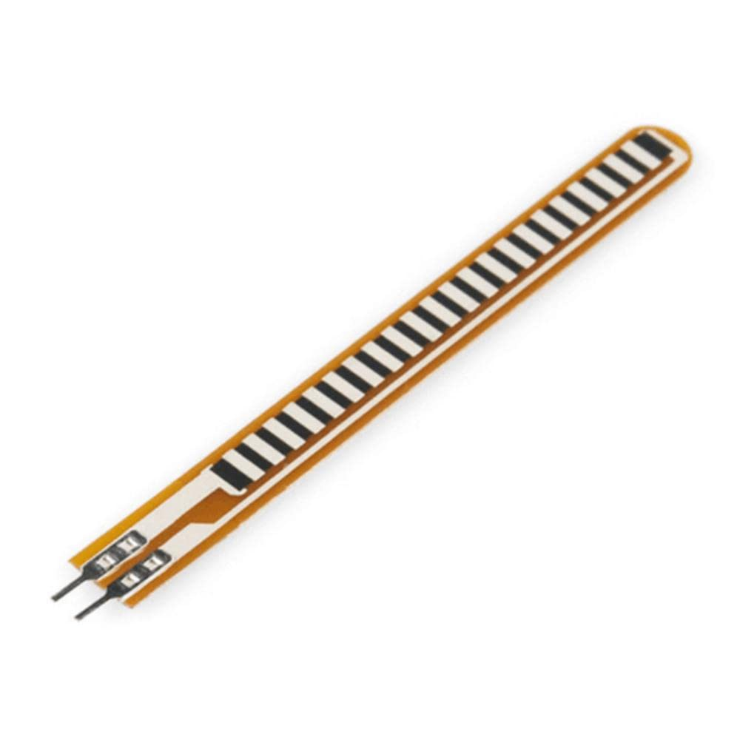
Fig: 4.5.2 Flex Sensor.

Features:

- Construction: simple in construction
- Cost: low cost.
- Temperature Range: -35°C to +80°C.
- Resistance: Incresases between 30-40KOhms
- Size: comes in two sizes of 2.2" and 4.5".

- MPU6050 Gyroscope

The MPU-6050 is a motion tracking device that has a 3-axis gyroscope and is part of an Inertial Measurement Unit (IMU) . The MPU-6050 can detect changes in acceleration, rotation, and motion. It provides motion data like pitch, roll, yaw, landscape, portrait sense, and angles. The MPU-6050 has a Digital Motion Processor (DMP) that performs complex calculations and frees up the microcontroller's work. The DMP combines data from the accelerometer and gyroscope to compute orientation and apply offsets.
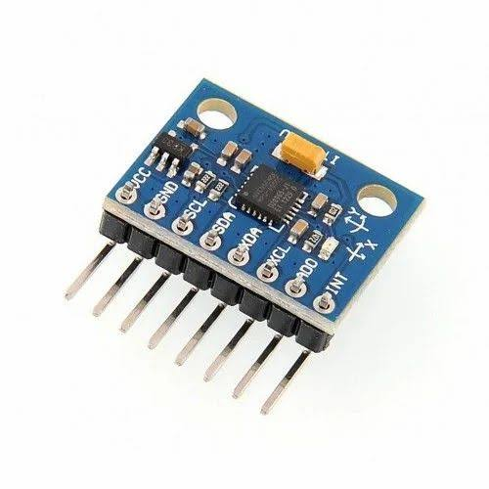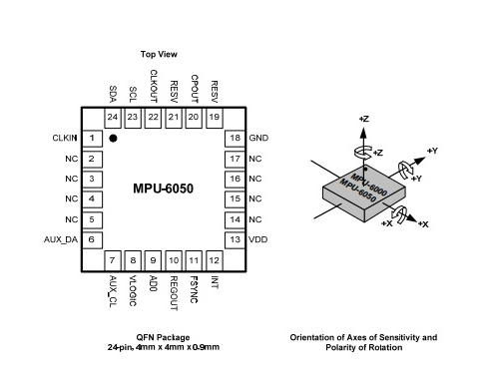
Fig: 4.5.3 MPU6050 Gyroscope. Fig: 4.5.4 MPU6050 Pinout Diagram

Features:

- Sensitivity: Up to 131 LSBs/dps
- Full-scale range: ±250, ±500, ±1000, and ±2000dps
- Digital Motion Processing (DMP) engine: Offloads complex motion fusion, sensor timing synchronization, and gesture detection
- Embedded algorithms: For run-time bias and compass calibration
- Digital-output temperature sensor: Available
- Digital input on FSYNC pin: Supports video Electronic Image Stabilization and GPS

- Zigbee transmitter
A ZigBee transmitter is a device that uses a set of communication protocols to enable short-range wireless networking. ZigBee transmitters are designed for low-power, low-cost applications that require long battery life. Zigbee is a wireless smart home technology that's used in applications like wireless light switches, home energy monitors, and traffic management systems. It's also used in the Internet of Things (IoT).
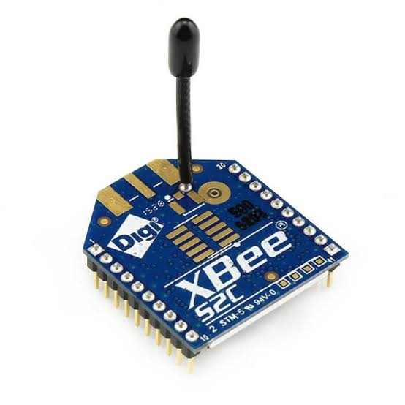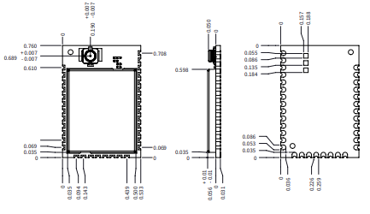
Fig: 4.4.1 zigbee transmitter ` Fig: 4.4.2 pinout diagram
Features:
- Frequency bands: ZigBee transmitters can operate in 868 MHz, 915 MHz, and 2.4 GHz frequency bands.
- Data rate: The maximum data rate for a ZigBee transmitter is 250 kilobits per second. Transmission distance: ZigBee transmitters can transmit data over a distance of 10–100 meters (33–328 ft) in a line of sight.
- Mesh networking: ZigBee devices can transmit data over longer distances by passing it through a mesh network of intermediate devices.
- Encryption: ZigBee networks use 128-bit symmetric encryption keys for security.
- Components: A digital ZigBee transmitter includes a Cyclic Redundancy Check, Bit-to-Symbol block, Symbol-to-chip block, Modulator, and Pulse shaping block

- Wireless camera
WiFi camera module supports the connection between the camera and the high-definition camera WiFi module through WiFi signal, and also supports the connection of the drive-free camera to the high-definition camera WiFi module through the USB interface.
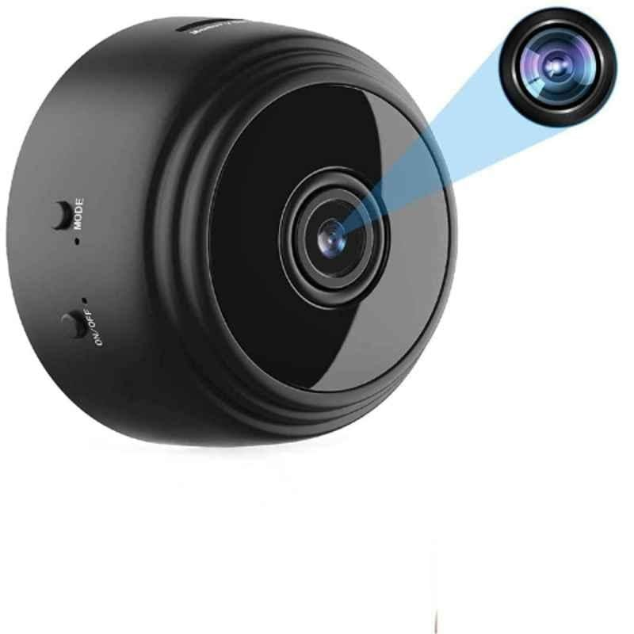
Fig: 4.5.5 Wireless camera.

- L293 Motor driver
The L293D is designed to provide bidirectional drive currents of up to 600-mA at voltages from 4.5 V to 36 V. Both devices are designed to drive inductive loads such as relays, solenoids, DC and bipolar stepping motors, as well as other high-current/high-voltage loads in positive-supply applications.
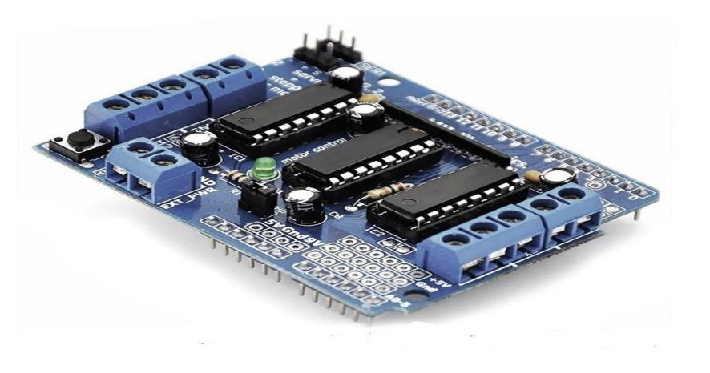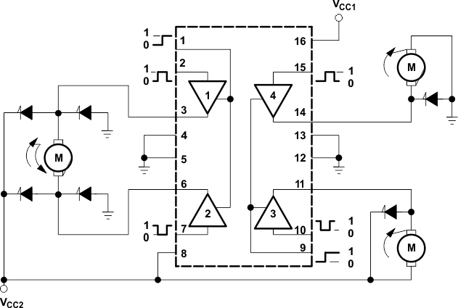
Fig: 4.5.6 L293 motor driver. Fig: 4.5.7 L293 motor pinout diagram
- Servo motor
A servo motor is a compact, powerful, and energy-efficient device that rotates or pushes parts of a machine with precision. They are used in many industrial and commercial applications, including robotics, camera auto focus, and smart positioning.
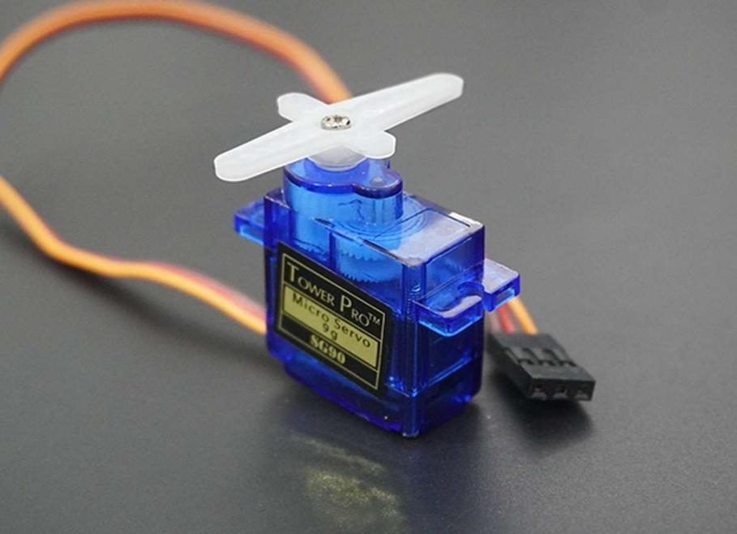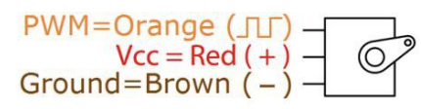
Fig: 4.5.7 Servo motor. Fig:4.5.8 Pinout Digram
- Zigbee receiver
A ZigBee receiver is an end-user device that receives information from other devices in a ZigBee network, but cannot send information itself. ZigBee is a wireless networking protocol that allows devices to communicate with each other over short ranges. Here are some details about ZigBee receivers.


Fig. 4.8 zigbee receiver

Features:
- Range: ZigBee devices can transmit data over a range of 10–100 meters in line-of-sight, depending on the power output and environmental conditions.
- Battery life: ZigBee devices are power-efficient and can operate for several years before needing a new battery.
- Security: ZigBee networks use 128-bit symmetric encryption keys to secure communication.
- Data rate: ZigBee has a defined rate of up to 250 kbit/s, which is best suited for intermittent data transmissions.
- Wires
Wires are essential components in numerous electrical and electronic systems, serving as conduits through which electric current flows. Typically made from metals such as copper or aluminium due to their excellent conductivity, wires are used to connect various components within a circuit, enabling the transmission of power and signals across devices.
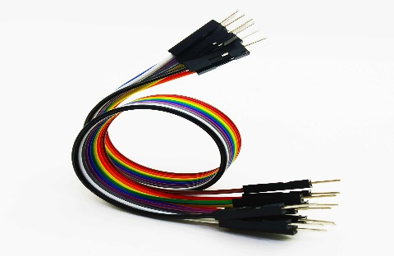
Fig: 4.5.9 Wires.
They come in various sizes and types, including solid and stranded forms, each suited to different applications based on flexibility and conductivity needs.

4.6 Software requirements

- Arduino IDE
The Arduino Integrated Development Environment (IDE) is a software that allows users to write code for Arduino boards and upload the code to the boards. The IDE is available in two editions. It is compatible with Windows, macOS, and Linux operating systems.

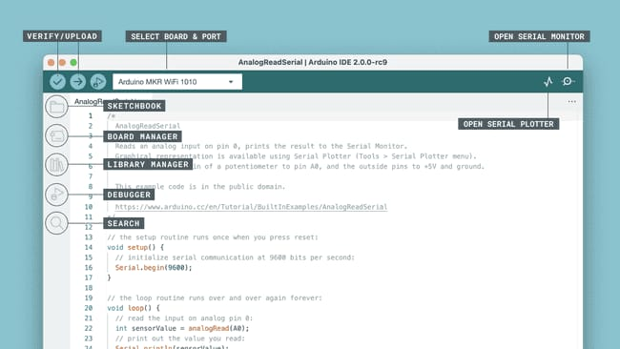
Fig: 4.6.1 Arduino IDE software.
- Text editor: Users can write code in the text editor.
- Sketchbook: Users can store their programs, or sketches, in the sketchbook.
- Tabs: Users can manage sketches with multiple files, each appearing in its own tab.
- Uploading: Users can upload sketches to the Arduino board by selecting the correct items from the Tools > Board and Tools > Port menus.
- Libraries: Users can use libraries to add extra functionality to their sketches.
- Serial Monitor: Users can view serial sent from the Arduino board over USB or serial connector.
- Preferences: Users can set preferences in the preferences dialog.
- Debugger tool: Users can use the debugger tool to test and debug programs.
The Arduino IDE is considered simple to use, which is one of the reasons for its popularity.

- CAD Design
CAD is a software-based process that allows users to digitally create 2D drawings and 3D models of products before they are manufactured. It is an important part of the design process because it provides precise instructions. CAD is used by designers and engineers in many industries, including architecture and engineering.
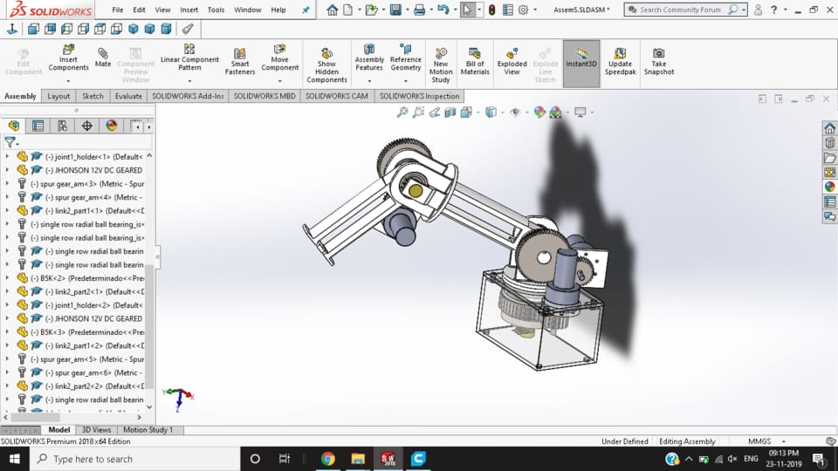
Fig: 4.6.2 CAD design software.
- Proteus
Proteus is used to create schematics and electronic prints for manufacturing printed circuit boards (PCBs). It's also used for rapid prototyping and virtual prototyping, which allows system testing before ordering a physical PCB. Proteus supports analog and digital signal simulation, and microcontroller simulation. It also has a large library of embedded simulation peripherals, and supports over 750 microcontroller variants. It can be purchased in many configurations, depending on the size of designs being produced and the requirements for microcontroller simulation.

Fig: 4.6.3 Proteus software.

CHAPTER 5

CONCLUSION AND FUTURE SCOPE

  - Application of the system.
- Space Exploration:
Arms on rovers like Curiosity and Perseverance perform tasks such as drilling, sample collection, and analyzing soil and rock. They help in assessing the planet's geology and potential for past life. Robotic arms are used to collect lunar samples and deploy scientific instruments on the Moon’s surface.
- Industrial Automation:
Robotic arms automate assembly lines, handling tasks like welding, painting, and material handling, improving efficiency and precision. They can be equipped with sensors to inspect products for defects and ensure quality standards.
- Agriculture:
Robotic arms assist in planting, weeding, and harvesting crops, using data to optimize yield and reduce waste. Equipped with sensors, these arms can analyze soil quality and nutrient levels, aiding in sustainable farming practices.
- Medical Applications:
Robotic arms assist in minimally invasive surgeries, providing greater precision and control than human hands. Examples include the da Vinci Surgical System. Robotic arms are used in physical therapy to assist patients with mobility exercises and recovery.
- Underwater Exploration:
Robotic arms on underwater drones and submersibles are used for tasks such as sampling marine life, inspecting underwater structures, and conducting research in deep-sea environments.
- Disaster Response:
Robotic arms can manipulate debris, search for survivors, and deliver supplies in hazardous environments, such as during earthquakes or building collapses. They are used to manage and contain chemical spills or nuclear incidents, reducing human risk.
- Entertainment and Art:
Robotic arms can be programmed to paint, sculpt, or create music, exploring the intersection of technology and art. They are used in animatronics for creating interactive experiences and attractions.
- Research and Development:
Robotic arms can automate experiments in laboratories, handling various materials to test their properties under different conditions. In engineering and design, robotic arms assist in creating prototypes quickly and accurately.
- Logistics and Warehousing:
Robotic arms are used for sorting, packing, and retrieving goods in warehouses, enhancing efficiency in supply chain management. Some applications involve robotic arms in autonomous delivery vehicles or drones, handling packages directly.
- Consumer Applications:
Robotic arms are integrated into home robots for tasks like cleaning, cooking, and other household chores. Used in STEM education, robotic arms help students learn programming, mechanics, and robotics through hands-on projects.
- Military and Defense:
Robotic arms can perform tasks such as bomb disposal, reconnaissance, and logistics support in combat zones, reducing risk to personnel.

Advantages.

- High Precision:
Robotic arms can perform tasks with a level of precision that exceeds human capabilities, which is essential in environments where exact measurements are critical. They can repeatedly perform the same task with uniform accuracy, minimizing errors and variations.
- Enhanced Dexterity:
Equipped with multiple joints and degrees of freedom, these arms can maneuver in tight spaces and perform intricate tasks that are challenging for humans. They can be fitted with various tools and sensors, allowing them to adapt to different tasks, from handling delicate samples to assembling components.
- Operational Safety:
Robotic arms can operate in dangerous settings (e.g., space, nuclear sites, underwater) where human presence is risky, minimizing the potential for injury. They can be controlled remotely, allowing operators to stay at a safe distance while still performing necessary tasks.
- Increased Efficiency:
Unlike humans, robotic arms can work continuously without breaks, significantly increasing productivity. Automation of repetitive tasks speeds up operations, allowing for faster project completion.
- Cost-Effectiveness:
Reducing the need for human labor in repetitive or dangerous tasks can lead to significant cost savings. Their precision reduces the risk of costly mistakes in manufacturing and other processes.
- Data Collection and Analysis:
Robotic arms can be equipped with sensors for real-time data collection, enabling detailed analysis and monitoring of processes. Advanced robotic systems can make decisions based on data input, optimizing processes without human intervention.
7. Adaptability:
Robotic arms can be reprogrammed for different tasks, making them suitable for a wide range of applications without the need for extensive retooling. They can be integrated into existing systems easily and scaled according to project requirements.
8. Improved Quality Control:
Automated processes help maintain quality standards by reducing human variability. Integrated systems can provide immediate feedback on quality metrics, enabling rapid adjustments.
9. Research and Development:
In space exploration, robotic arms allow scientists to conduct experiments and gather samples from environments that are otherwise inaccessible. In manufacturing, they can be used to test and develop new materials under controlled conditions.
10. Enhanced Human-Robot Collaboration:
Collaborative robots (co-bots) can work alongside humans, assisting in complex tasks and enhancing overall productivity through teamwork. Robotic arms can assist in training environments, providing hands-on experience without the risks associated with live operations.

Conclusion
As we conclude this phase of the project, we stand at the threshold of a remarkable journey.The Robotic Rover Arm offers enhanced efficiency through real-time data analytics, proactive maintenance, and optimal performance tracking.
With the groundwork firmly established, our project stands poised for success as we transition from the careful planning and design phases to the imminent hardware development stage in the upcoming semester. The precision in conceptualization and a well-defined vision set the stage for a promising journey ahead.
This approach facilitates timely detection of faults, improves energy yield, and ensures overall system reliability. As technology advances, integrating AI and machine learning further refines the monitoring process, making it a pivotal tool in managing and maximizing the output of solar energy systems.
Entering the subsequent phase, these concepts will transform into a concrete and operational system, materializing our vision into a tangible reality. In Robotic Rover Arm, the sensors collect real-time data on various parameters. This data is then transmitted to a central hub, where advanced analytics and algorithms process it, enabling proactive decision-making and overall efficiency of the Robotic Rover Arm.
As we embark on the construction of the hardware in the upcoming semester, witnessing our ideas materialize, we inch closer to unlocking the complete potential of this project. The application of Arduino based system in a Robotic Rover Arm, ensures the timely detection, and enhances overall system efficiency through real-time data analytics.
In essence, this project signifies the thrilling shift from conceptualization to implementation, marking the beginning of transforming these ideas into tangible reality. As we delve into the hardware development phase, the realization of our vision for a cleaner, greener, and more efficient future, with anticipation for the promising stages that lie ahead.

5.4 Future scope

1. Advanced Manufacturing:
Integration with AI and IoT will lead to fully automated, adaptive manufacturing environments where robotic arms can communicate and collaborate with other machines and human workers. As consumer demand shifts toward personalized products, robotic arms will be capable of flexible manufacturing, allowing for customized production runs without significant downtime.
- Healthcare Innovations:
Robotic arms will play a critical role in teleoperated surgical systems, allowing surgeons to perform procedures from remote locations with high precision. Advanced robotic arms will assist in rehabilitation therapies, providing personalized movements and feedback for patients recovering from injuries.
- Agricultural Advancements:
Future robotic arms will enable fully autonomous farming operations, including planting, harvesting, and crop monitoring, driven by AI and machine learning algorithms for optimal yield. These technologies will facilitate precision agriculture, helping to minimize resource usage (water, fertilizers) and environmental impact.
- Disaster Response and Recovery:
Enhanced robotic arms will be employed in disaster zones for search and rescue, debris removal, and handling hazardous materials, with improved dexterity and sensory capabilities. They will be instrumental in environmental remediation efforts, capable of operating in contaminated or unsafe areas.
- Robotics in Education and Training:
Educational institutions will increasingly use robotic arms to teach students about engineering, robotics, and programming, fostering a new generation of innovators. Robotic arms can simulate real-world tasks for training purposes, enhancing skill development in various industries.
- Collaborative Robotics (Co-Bots):
As workplace dynamics evolve, co-bots will work alongside humans in more complex environments, learning from human actions and improving task efficiency. Future co-bots may be designed with better social interaction capabilities, enabling them to understand and respond to human emotions and cues.
- Integration with AI and Machine Learning:
AI-driven robotic arms will analyze data in real time to make informed decisions, optimizing processes across various applications. Machine learning will enable robotic arms to learn from experiences, improving their performance and adaptability in dynamic environments.
- Underwater and Space Robotics:
Robotic arms will advance underwater exploration technologies, enabling deeper and more complex missions to study marine ecosystems. Future missions to the Moon and asteroids will utilize robotic arms for mining operations and in-situ resource extraction.
- Integration with Emerging Technologies:
Robotic arms could be integrated with VR/AR systems for training and simulation, providing immersive environments for skill development and operational planning. Implementing blockchain technology could enhance the traceability and efficiency of robotic operations in supply chains.

REFERENCES
[1] W. Afzal, S. Iqbal, Z. Tahira, and M. E. Qureshi, “Gesture control robotic arm using flex sensor,” Applied and Computational Mathematics, vol. 6, no. 4, pp. 171–176, July 2017.
[2] C. Preetham, G. Ramakrishnan, S. Kumar, A. Tamse, and N. Krishnapura, “Hand talk-implementation of a gesture recognizing glove,” in Proc. of the 2013 Texas Instruments India Educators’ Conf. (TIIEC 2013), Bangalore, India, pp. 328–331, Apr. 2013.
[3] M. A. Doshi, S. J. Parekh, and M. Bhowmick, “Wireless robotic hand using flex sensors,” Int. J. of Scientific & Eng. Research, vol. 6, no. 3, pp. 1471–1474, Mar. 2015.
[4] K. Roy, D. P. Idiwal, A. Agrawal, and B. Hazra, “Flex sensor based wearable gloves for Robotic gripper control,” in Proc. of the 2015 Conf. on Advances In Robotics (AIR 2015), Goa, India, pp. 1–5, July 2015.
[5] T. Fegade, Y. Kurle, S. Nikale, and P. Kalpund, “Wireless gesture controlled semi-humanoid robot,” in Proc. of the 2016 Int. Conf. on Recent Advances and Innovations in Eng. (ICRAIE 2016), Jaipur, India, pp. 1–5, Dec. 2016.
[6] J. Jiang, A. McCoy, E. Lee, and L. Tan, “Development of a motion controlled robotic arm,” in Proc. of the 8 th IEEE Annual Ubiquitous Computing, Electronics & Mobile Commun. Conf. (UEMCON 2017), New York City, NY, USA, pp. 101–105, Oct. 2017.
[7] P. Atre, S. Bhagat, N. Pooniwala, and P. Shah, “Efficient and feasible gesture controlled robotic arm,” in Proc. of the 2 nd Int. Conf. on Intelligent Computing and Control Systems (ICICCS 2018), Madurai, India, pp. 1070–1075, June 2018.
[8] A. B. Bakri, R. Adnan, and F. A. Ruslan, “Wireless hand gesture controlled robotic arm via NRF24L01 transceiver,” in Proc. of the 9 th IEEE Symp. on Computer Applications & Industrial Electronics (ISCAIE 2019), Kota Kinabalu, Malaysia, pp. 16–22, Apr. 2019.
[9] P. Sihombing, R. B. Muhammad, H. Herriyance, and E. Elviwani, “Robotic arm controlling based on fingers and hand gesture,” in Proc. of the 3 rd Int. Conf. on Mechanical, Electronics, Computer, and Industrial Technol. (MECnIT 2020), Medan, Indonesia, pp. 40–45, June 2020. [10] J. Paterson and A. Aldabbagh, “Gesture-controlled robotic arm utilizing OpenCV,” in Proc. of the 3 rd Int. Congress on Human-Computer Interaction, Optimization and Robotic Applications (HORA 2021), Ankara, Turkey, pp. 1–6, June 2021.
[11] S. Gupta, A. Rana, U. P. Kumar, V. Rathi, R. Kalra, and K. Balasubramanyam, “Gesture controlled robotics arm using image processing,” in Proc. of the 5 th Int. Conf. on Contemporary Computing and Informatics (IC3I 2022), Uttar Pradesh, India, pp. 821–826, Dec. 2022.
[12] M. M. U. Saleheen, M. R. Fahad, and R. Khan, “Gesture-controlled robotic arm,” in Proc. of the 2023 Int. Conf. on Computer Science, Information Technol. and Eng. (ICCoSITE 2023), Jakarta, Indonesia, pp. 495–499, Feb. 2023.

